**Devops Capstone Project 2**You are hired as a DevOps Engineer for Analytics Pvt Ltd. This company is a

product based organization which uses Docker for their containerization needs

within the company. The final product received a lot of traction in the first few

weeks of launch. Now with the increasing demand, the organization needs to

have a platform for automating deployment, scaling and operations of application

containers across clusters of hosts. As a DevOps Engineer, you need to

implement a DevOps lifecycle such that all the requirements are implemented

without any change in the Docker containers in the testing environment.

Up until now, this organization used to follow a monolithic architecture with just 2

developers. The product is present on: https://github.com/hshar/website.git

Following are the specifications of the lifecycle:

1. Git workflow should be implemented. Since the company follows a

monolithic architecture of development, you need to take care of version

control. The release should happen only on the 25th of every month.

2. CodeBuild should be triggered once the commits are made in the master

branch.

3. The code should be containerized with the help of the Dockerfile. The

Dockerfile should be built every time if there is a push to GitHub. Create a

custom Docker image using a Dockerfile.

4. As per the requirement in the production server, you need to use the

Kubernetes cluster and the containerized code from Docker Hub should be

deployed with 2 replicas. Create a NodePort service and configure the

same for port 30008.

5. Create a Jenkins Pipeline script to accomplish the above task.

6. For configuration management of the infrastructure, you need to deploy the

configuration on the servers to install necessary software and

configurations.

7. Using Terraform, accomplish the task of infrastructure creation in the AWS

**Step 1: Created Worker1 EC2 instance on AWS**  
-Installed Jenkins,java and Terraform.  
  
**Step 2: Created Terraform script main.tf to create 2 EC2 instance**   
  
kub-master and kub-slave  
  
  
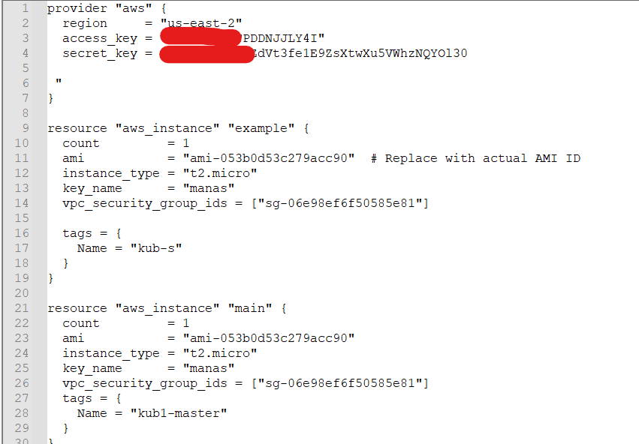  
  
$Terraform init  
  
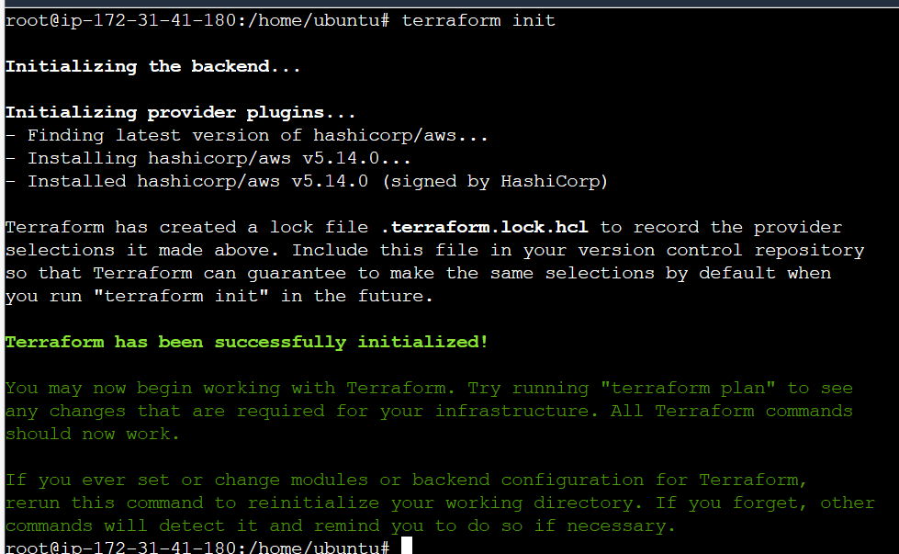

$Terraform apply  
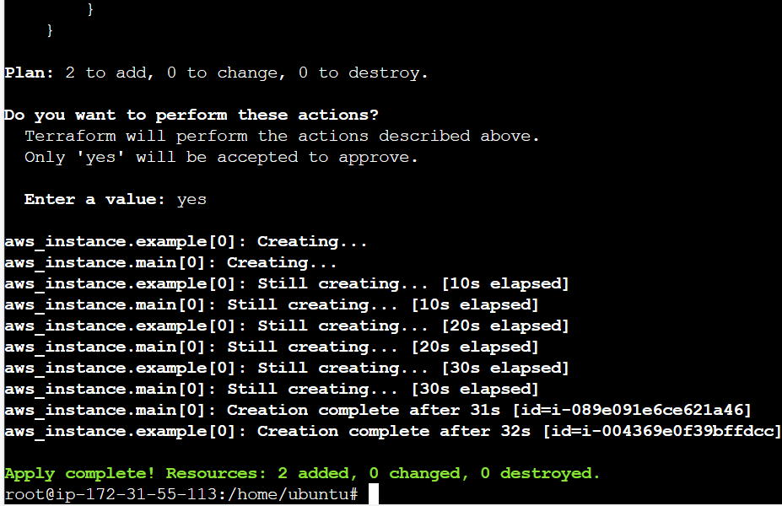  
  
Output:  
  
  
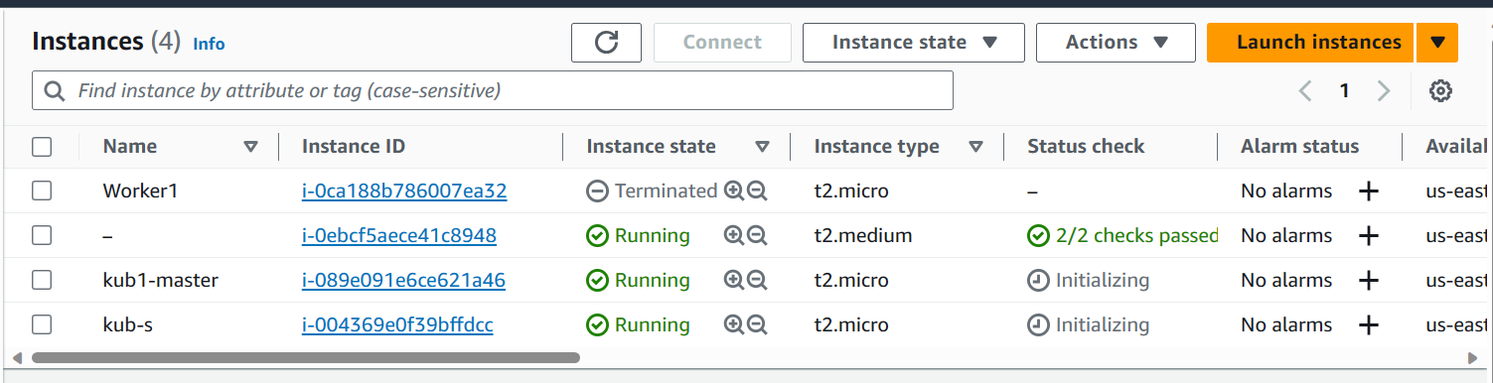  
  
**Step 3: Installed kubernetes and docker on kub-master and kub-slave  
  
than Confirgured the kubernetes cluster**  
  
  
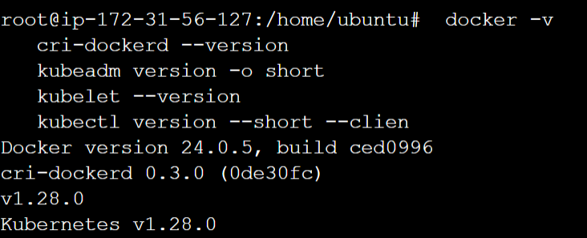  
  
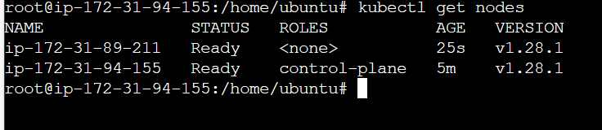  
  
  
  
  
  
**Step 4: Created kub-master node on Jenkins**  
  
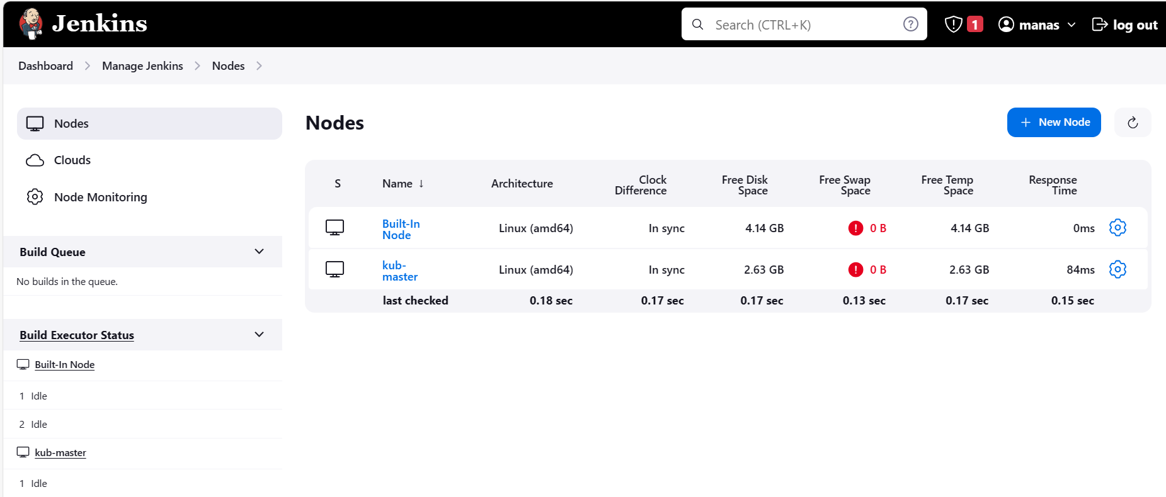  
  
  
**Step 5: Added docker hub credentials in Jenkins credential manager**  
  
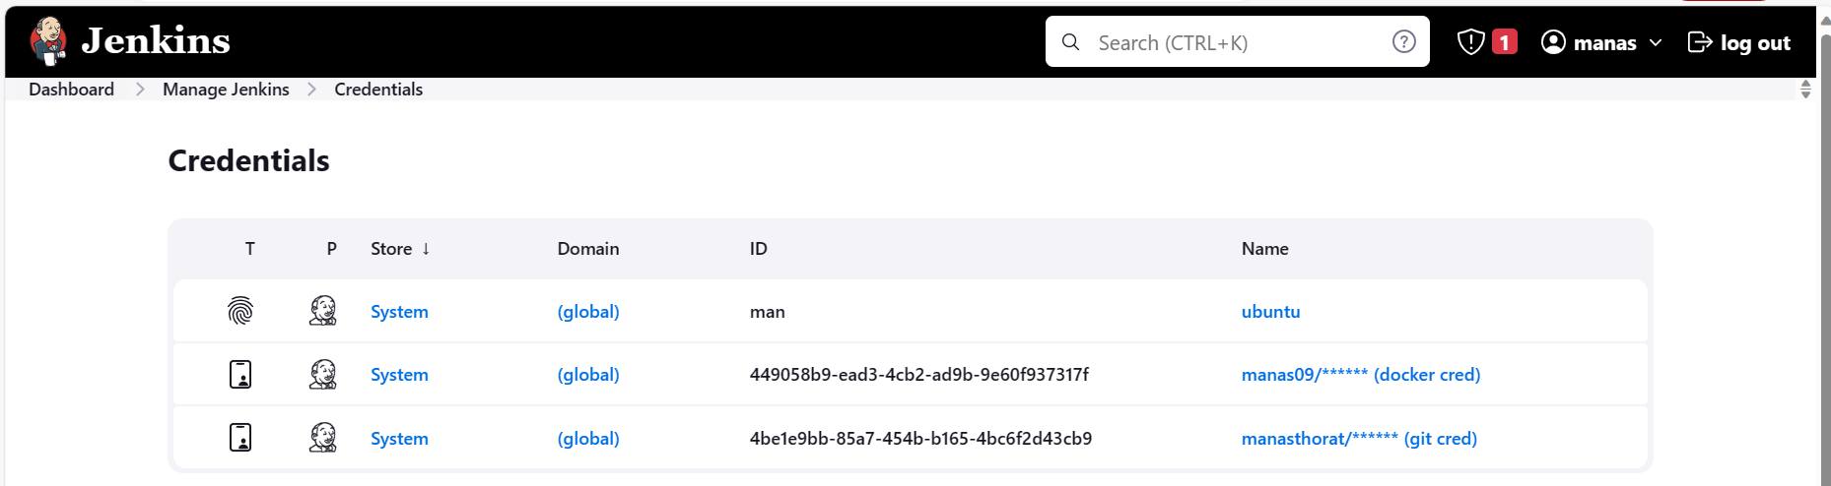  
  
  
  
**Step 6: Created a Jenkins pipeline:**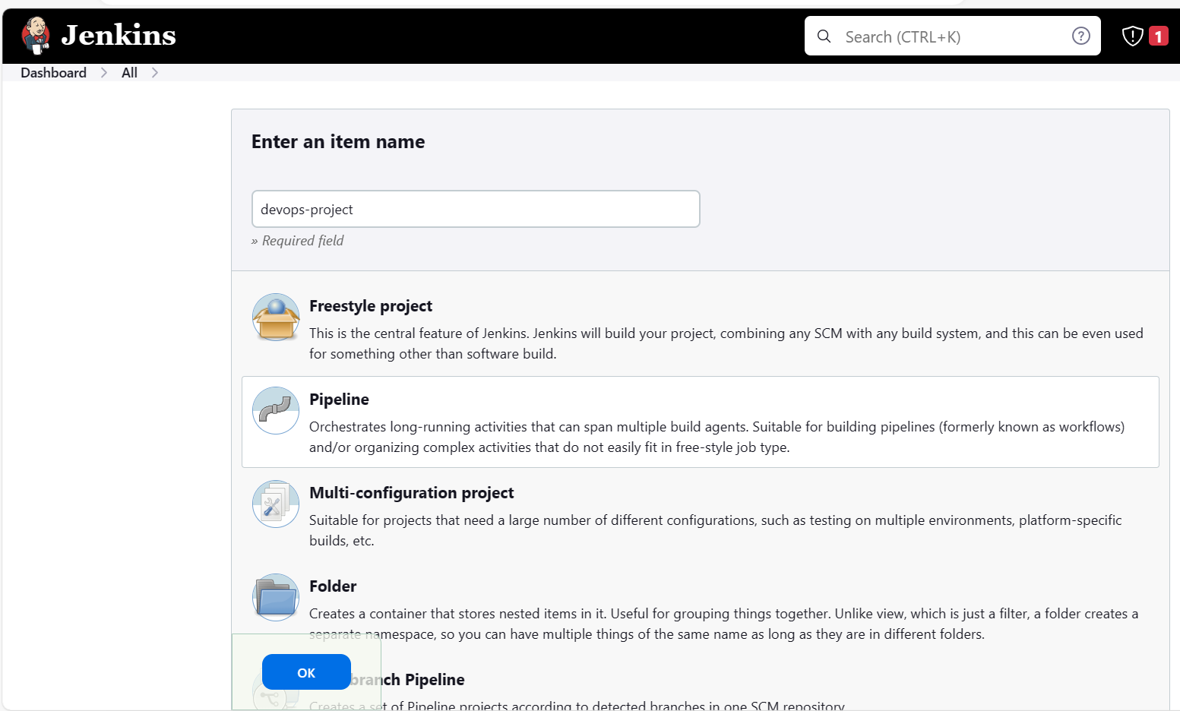  
  
  
**Step 7: Git repository -** [**manasthorat/website (github.com)**](https://github.com/manasthorat/website) **Step 8: Dockerfile  
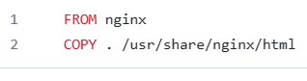  
  
Step 9:Service.yml  
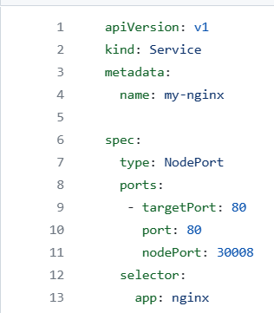  
Step 10: Deploy.yml  
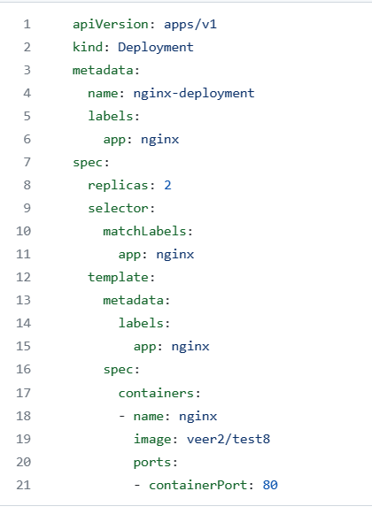  
  
Step 11: Jenkins pipeline script**  
  
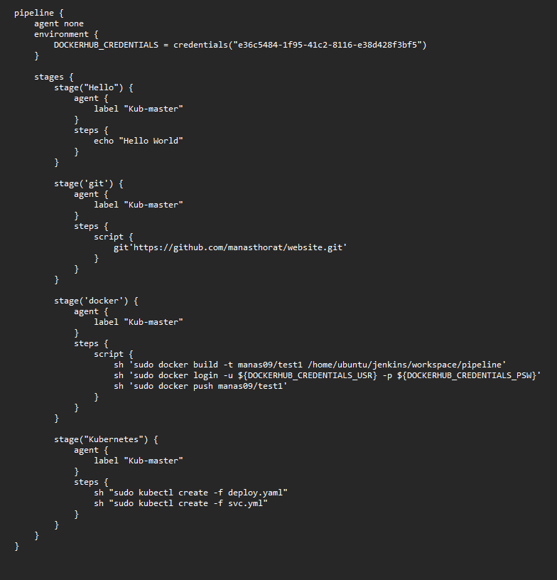  
  
  
  
Output:  
  
  
